# **Guide to Accessing and Navigating the CIES 2025 Hub**

## **Event: CIES 2025 – Envisioning Education in a Digital Society**

## **Date: March 22-26, 2025**

## **Location: Chicago, IL & Online**

## **Access:** [**https://conference.cies.us/**](https://conference.cies.us/)

**Accessing the CIES 2025 Conference Page**

**Step 1:** Open a web browser  Use Google Chrome, Mozilla Firefox, or Microsoft Edge for better compatibility.

**Step 2:** Go to the official website  Visit:<https://conference.cies.us/> Once inside, you will find several options on the homepage:

●      **ONLINE MEETING HUB** – Access virtual sessions and online resources. You must be logged in to enter.

●      **PROGRAM** – Explore the full conference program with filters by date and session type.

●      **ALL ACADEMIC** – Check your reviews

●      **REGISTRATION** – Register here.

●      **CONFERENCE THEME** – Learn about the event’s focus and key topics.

**Accessing the Online Meeting Hub**

To enter the Online Meeting Hub, you must meet the following requirements:

●      You must have an active CIES membership or a "Submitter Only" account. If not, you will see this message: "You must have a current CIES membership or a CIES 'Submitter Only' account-type to login."

●      If your CIES membership has expired, you need to renew it by clicking the corresponding link.

●      If you are not a CIES member, you can create a "Submitter Only" account by following the instructions on the page.

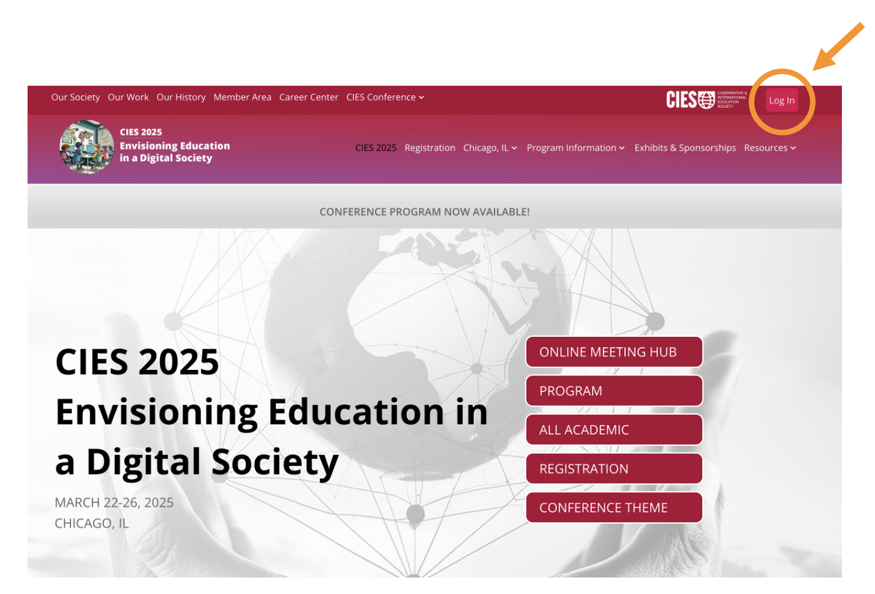

**Click-on** **ONLINE MEETING HUB**

●      Click on "Log in" on the top right corner of the page



(If you are not logged in, you will see this message: "You must be logged in to access this resource. Please log in to continue.")

●      Enter the email and password you used for registration.

●      If you forgot your password, use the password recovery link.

**Reasons why you must “Log In”**

●      Access live conferences and sessions in the ONLINE MEETING HUB.

●      View your personalized agenda in “Your Sessions”.

●      Access to Congress updates.

**Tips for a Better Experience during the Virtual Sessions**

●      Ensure you have an active membership before the event to avoid access issues.

●      Use a stable internet connection to prevent interruptions in live sessions.

●      Check your time zone and schedule sessions of interest in your calendar.

**Navigating the CIES 2025 Hub**

Once you have logged into the CIES 2025 Hub, you will have access to several options that help you navigate and make the most of the conference.

**Main Navigation Menu**

At the top of the page, you will find the following options:

1. **HOME**

●      Main page with “Highlighted Sessions”

●      "Today at CIES 2025" section with the main daily activity schedule.

●      Option to adjust the time zone to view sessions in your local time.

**2. PROGRAM**

●      Access the complete conference agenda by day.

●      Filter sessions by start time, session title and SIG.

●      Session details, including times, speakers.

* On the left side, you will find the live sessions. You can only access the virtual ones; the onsite sessions are available in person only. On the right side, you will find the upcoming sessions.

**3.**  **POSTERS PRESENTATIONS**

* Exhibition of asynchronous posters presented with interaction through chat

**4. BOOK LAUNCHES**

●      Exhibition of asynchronous books launches with interaction through chat.

●      Section for the presentation of new books.

●      Information on authors, publishers, and book availability.

**5. VIRTUAL EXHIBIT**

* The virtual exhibit includes All, On-site Exhibitors, Information Table, and Artisan Corner.

**6. YOUR SESSIONS**

●      View and be able to find any sessions associated with your account

**7. SPONSORS**

●      Information about conference sponsors.

**8. REGISTER**

* Here you can register if you have not.
* In this session, changes about personal information are disabled. To make any updates, please use the CIES site first.

**9. HELP**

●    Support section for access or navigation issues.

* In the Help section, you can find options for addressing issues related to audio/video, book launch, connection, login, payment, posters, program/schedule, registration, and the virtual book exhibit.

●   Frequently asked questions and contact for assistance.

**10. LOGOUT**

●    Securely log out of your account.

**How to Access Virtual Sessions**

**For Presenters, Chairs, Discussants and Organizers:**

Once inside the Hub, navigate to the **"My Sessions"** section. There, you will find a list of your scheduled sessions along with a button that allows them to connect to the live session.

To join a virtual session, you must access the Hub at least **15 minutes before** the session starts.

It is important to join early to ensure a smooth connection and resolve any technical issues before the session begins.

**For attendees who are not presenting:**

To join a virtual session, you must access the CIES Hub at the scheduled time to enter the 'virtual room' where the session takes place. You will find the live sessions in the 'Program' section (left side), and by selecting one, you can enter the session. Sessions will open 5 minutes before they start, and you will wait in the waiting room until the session starts.